Request for Subaward Applications
A. Introduction
Mt. Ascutney Hospital and Health Center (MAHHC) anticipates making subawards available under the Prevention Network Grant (PNG), expected to be awarded to MAHHC by the State of Vermont. The Prevention Network Grant is a federally funded award under the State Opioid Response Program, CFDA No. 93.788, funded through the Substance Abuse and Mental Health Services Administration (SAMHSA). This subaward process is the responsibility of the Community Health Department at MAHHC and is being coordinated by two Regional Prevention Program Managers. If MAHHC does not receive the expected funding from the state of Vermont, or funding is received on a schedule that impacts dates in this RFA, MAHHC reserves the right to cancel or amend this RFA.
Anticipated total funds available through Prevention Network Grant contracts and subawards: $200,000
Applicants may request up to $20,000. There is no lower limit on funding requests. Amounts requested should be proportional to the needs addressed/population impacted and realistic to expend in the project period.
Application Due Date: September 21, 2020
Questions on this RFA should be submitted by email to Subawards@mahhc.org with the subject line “Re: RFA Question” by 5:00 pm on August 24, 2020. Submitted questions will be addressed in a Q&A webinar to be held on August 26 at 10 a.m. Additional questions posed during the webinar will be answered as time allows. Prospective applicants are strongly encouraged to attend the Q&A webinar [click on hyperlink to register]. Following the webinar, questions and corresponding answers will be posted on the Prevention Network webpage: http://mappvt.org/PNGgrant.
B. Program Description
Primary prevention is the proactive promotion of healthy lifestyles and norms that reduce the risks associated with substance use, and the promotion of protective factors that support the health and well-being of the population. Primary prevention is considered “Universal” and tends to impact large groups. Secondary prevention aims to reduce the impact on those at higher than average risk for substance misuse, as well as those individuals currently experiencing problems related to use. Secondary prevention is considered “Selective” and tends to impact individuals, families, or small groups.
The short-term goal of this Prevention Network opportunity is to build primary and secondary prevention capacity and infrastructure at the community and regional levels, with long-range goals of reducing the misuse of:
- Alcohol
- Marijuana
- Tobacco
- Prescription drugs, including prescription opioids and stimulants
- Illicit stimulants (e.g., cocaine) and illicit opioids (e.g., heroin)
- Other drugs (e.g., methamphetamine)

Social Determinants of Health (SDoH) are the conditions in which people are born, grow, live, work and age, and those conditions shape health. The term SDoH has very broad implications, covering areas such as housing, employment, and education, among others. Prevention strategies, in practice, impact several key components of the SDoH model, including culture, healthy child development, social/physical environments, and social support networks, as indicated in the graphic below. Any social determinant of health may be addressed under this RFA as long as the proposal is linked to substance misuse prevention of any substance at any age.

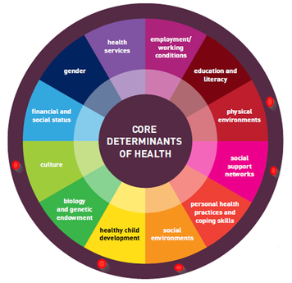

Just as we need food, shelter, and clothing, human beings also need strong and meaningful relationships and supportive, healthy environments to thrive. This RFA seeks innovative applications that increase the presence of the elements described above in our communities. (See Appendix A for examples.)
Achieving health equity requires that we focus on addressing health disparities. Applicants are encouraged to develop proposals designed to reduce health disparities impacting priority populations in our region, including:
- LGBTQ+ Vermonters, including children, youth, and young adults
- Racial and ethnic minorities
- Communities with high poverty rates and schools with high rates of children qualifying for free or reduced price lunch
A needs and disparities statement developed under the FY2020 Prevention Network Grant is available here: http://mappvt.org/PNGgrant . Applicants may find this document to be a useful resource when considering how their project might impact groups affected by health disparities.
The excerpt from Vermont’s State Health Improvement - Plan 2019-2023 on the following page helps illustrate the connection between health disparities, the social determinants of health, and risks for substance use. The complete SHIP can be accessed at: https://www.healthvermont.gov/sites/default/files/documents/pdf/ADM_State_Health_Improvement_Plan_2019-2023.pdf

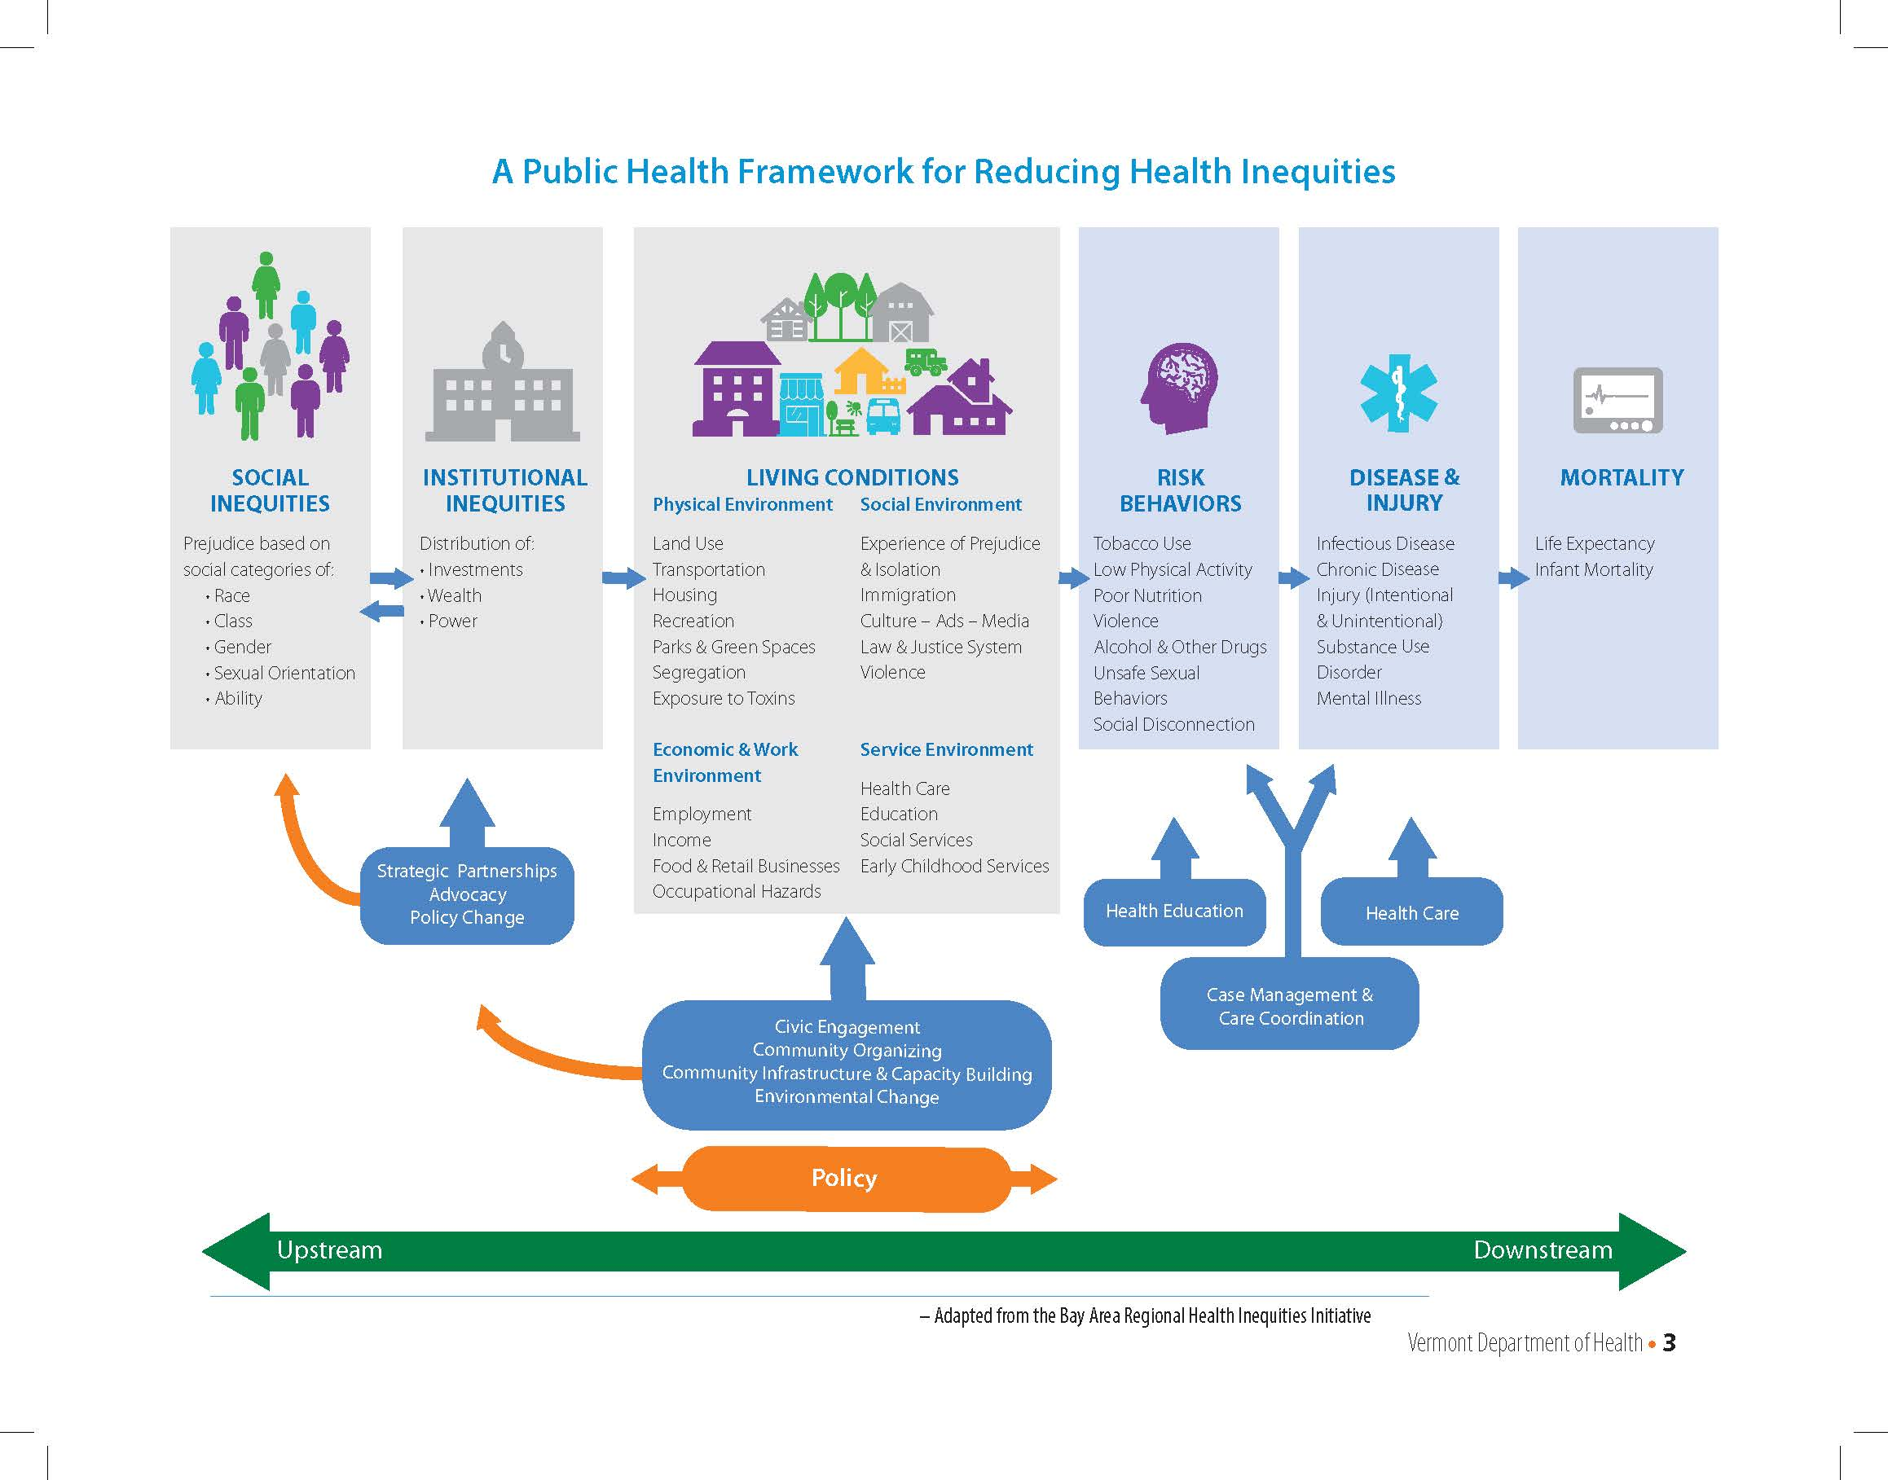

C. Subaward Information
MAHHC anticipates making subawards by no later than October 30, 2020, assuming timely receipt of Year 2 Prevention Network funding from the State of Vermont. The project period for subawards is a maximum of 10.5 months, from November 2, 2020 through September 15, 2021. All funded projects must be completed and all funds expended by no later than September 15, 2021.
Applicants are limited to one application per entity, however fiscal agents may be attributed on multiple applications.
Applicants may request up to $20,000. There is no lower limit on funding requests. Amounts requested are expected to be proportional to the needs addressed/population impacted.
D. Eligibility
The following organization types are eligible to apply for funding:
- Individual Schools
- Supervisory Unions
- Hospitals/Healthcare systems
- Nonprofits (examples include, but are not limited to: social service agencies, parent-child centers, regional planning commissions, and organizations that provide resources and programming to the public, such as libraries, arts organizations, etc.)
- Colleges and universities, including community colleges
- Municipalities
- Native American Indian Tribes recognized by the State of Vermont
- Faith-based organizations
- For-profit entities
Project activities must primarily impact the individuals or communities of one or more towns in the White River Junction and Springfield Offices of Local Health Service Areas:
- Barnard, Bethel, Bradford, Bridgewater, Chelsea, Corinth, Fairlee, Hartford (including Quechee, White River Junction, Wilder), Hartland, Norwich, Pomfret, Randolph, Rochester, Royalton, Sharon, Stockbridge, Strafford, Thetford, Tunbridge, Vershire, West Fairlee, Woodstock
- Andover, Baltimore, Cavendish, Chester, Grafton, Londonderry, Ludlow, Plymouth, Reading, Rockingham (including Bellows Falls), Springfield, Weathersfield, West Windsor, Weston, Windham, Windsor
Additional eligibility requirements:
- Collaborative proposals are welcome, but one entity must submit as the lead agent
- Individual persons are not eligible to apply
E. Preparing and Submitting Your Application
- Prospective applicants are strongly encouraged to attend the Q&A webinar on August 26, 2020 at 10:00 a.m. Interested parties can register for the webinar here.
- Organizations that intend to submit an application must submit a letter of intent by no later than 5:00 pm on September 4, 2020. The letter of intent form is accessible here. The purpose of this letter of intent is to provide the Program Managers with a preview of likely applicants. Letters of intent are required in order to be considered as an applicant but do not count towards application selection scoring.
- Applications must be submitted by email to Subawards@mahhc.org no later than 5:00 pm on September 21, 2020. Applications should be submitted in Word or PDF format only.
- Anticipated award date: no later than October 30, 2020.
- Projects may start as early as November 2, 2020. All projects must be complete and all funds expended by September 15, 2021.
- Applications should be submitted using the form in Attachment 1 to this RFA.
- Use resources to prepare your application - see section F. below.
F. Resources and Technical Support
For more information regarding substance misuse prevention strategies, please use the following resources prior to preparing your grant application.
Videos that describe the work of primary prevention:
https://www.addictionpolicy.org/what-is-prevention
About risk and protective factors:
NIDA
Youth_Substance_Use_Prevention_Infographic
About the VT Prevention Model (strategy approaches in relation to the number of persons impacted):
VT Prevention Model
For prevention strategy ideas that are evidence-based, effective, or found to be promising practices please use the following websites (provided as guidance, not required):
• https://www.blueprintsprograms.org/program-search/
• https://www.wsipp.wa.gov/BenefitCost
• https://www.ruralhealthinfo.org/project-examples/topics/substance-abuse
- https://ies.ed.gov/ncee/wwc/FWW

- http://www.promisingpractices.net/programs.asp

Applicants are required to submit a needs statement that should be supported by data. Applicants can use any valid data source, including data your organization collects for programmatic purposes. The Prevention Network Grant team tracks data for several indicators for Windsor and Orange counties. You can access the beta version of the Data Dashboard here.

For data that is searchable by Health Service Area or County levels:

AHS Community Profiles:
http://humanservices.vermont.gov/ahs_community-profiles

VT Department of Health Data Explorer:
https://apps.health.vermont.gov/ias/querytool

VT Youth Risk Behavior Surveys:
VT YRBS
G. Application Review Information
Each submitted application will undergo an initial screening for compliance with RFA requirements. Applications found to be incomplete or out of compliance will not be sent forward for merit review.
Each application will be read by a panel of at least 2 reviewers, who will rank each application. Some of the questions that will be considered by reviewers include:
- Is the project innovative? How does it connect to the long-term goals of reducing substance misuse?
- Does the project connect to the prevention components of the SDoH model and/or demonstrate the ability to build relationships and/or healthy environments?
- Does the project aim to positively impact one or more of the priority populations listed in Section D, above?
- Do the needs identified in the application justify the project? Does the data align with the proposed project?
- Does the proposal reasonably fit within the project period? Is the amount requested proportional to the needs addressed / population impacted?
- Does the workplan show a logical progression of activities?
- Does the service area align with the described geographic area outlined in Section D, above?
- Does the applicant demonstrate current internal capacity and resources to effectively address proposed activities?
In making funding decisions, the Prevention Network Program Managers will consider reviewer recommendations, as well as an interest in building a balanced subaward portfolio that reaches a variety of subpopulations and service areas. Reviewers may make partial funding recommendations. Program Managers reserve the right to request revisions on any application needing further clarification.
H. Award Expectations
The following expectations are applicable only if proposals are accepted for funding. The expectations are being provided here so that organizations can know what will be expected and realistically budget for time and effort of staff.
Prevention Network funds are granted to MAHHC through the Vermont Agency of Human Services, which requires that costs are incurred up front and then reimbursed at the end of a period, usually monthly or quarterly. This subaward opportunity allows for monthly invoicing.
Successful applicants will be asked to provide a copy of their most recent audit (if applicable) and a copy of their conflict of interest policy. These documents will be considered in shaping the monitoring plan for each subrecipient.
Monitoring methods will include, but are not limited to, review of monthly performance reports, comparison of invoiced costs to the approved budget, and phone check-ins. All subrecipients will be invited to the State of Vermont site visit with MAHHC. Participation is optional, but highly encouraged.
Applicants should be aware of the following information:
- All materials created under subawards funded through this RFA that are intended for use with the public, such as surveys, prevention toolkits, or educational materials (including but not limited to posters, flyers, brochures, presentations, videos) will be made available for use under the terms of a Creative Commons Attribution-NonCommercial-ShareAlike 4.0 International License and submitted with the appropriate monthly or final performance report.
- All subrecipients will be expected to attend a full-day Results-Based Accountability conference sponsored by MAHHC. Applicants should include costs for personnel and mileage in their budget planning.
- Subrecipients will be expected to:
  - Share prevention messaging through channels such as Facebook, websites, and newsletters, as applicable. Messaging will be provided to Subrecipients by the MAHHC Communication Specialist.
  - Disseminate information about training opportunities when requested by the MAHHC Communication Specialist.
I. Contact Information
Submit all correspondence regarding this RFA according to the instructions in the following table:
Email Address: | Subject Line | Send by Date: | Use this subject line to:
subawards@mahhc.org | Re: RFA Question | August 24, 2020 | Submit questions related to RFA for the Q&A Webinar
 | Re: PNG Application | September 21, 2020 | Submit application

APPENDIX A
Prevention Network Strategy Examples
The following table is offered as strategy examples that align with RFA Section B - Description. Applicants are not limited to these choices. See Needs & Disparities statement for ideas.
Increase Social-Emotional Learning  - Assess the capacity and need to address Social-Emotional Learning (SEL) of children  - Acquire and implement curriculum to address SEL needs of early childhood through high school youth  - Obtain Collaborative Problem Solving certification  - Implement the early MTSS model in an early childhood education center  - Establish mindfulness as a system-wide practice within a school or supervisory union | Strengthen Protective Factors through Environmental and Policy Enhancements  - Enhance school policy and culture to create supportive environments for students and staff who identify as LGBTQ+, racial and ethnic minorities, neuro-diverse and/or as individuals with disabilities  - Increase Restorative Practices in schools, businesses, towns  - Build community capacity for substance-free events  - Develop and implement town policies that create healthy environments for children, families, and people in recovery
Training, Assessment, and/or Strategic Planning  - Contract with Strategic Planning Consultant  - Launch task force to identify and address systemic issues that create barriers for low-income families, racial minorities, or other disadvantaged groups (e.g., zoning ordinances, hiring practices, etc.)  - Sponsor training session(s) for staff and/or community partners  - Conduct a survey to determine readiness to utilize identified program/curriculum (examples: SEARCH, GLSEN)  - Attend national or regional training (CADCA, National Prevention Network, Public Health Marijuana Summit) | Amplify Youth/Young Adult Voice  - Work with Youth Councils or student empowerment groups to identify and implement youth-led projects/events  - Support Youth and LGBTQ+ groups through community education to increase youth feeling they matter to the community  - Encourage youth/young adult involvement in substance misuse prevention through peer networks, mentoring, etc.  - Support youth in building off a Getting to Y analysis to target a specific area for improvement within a school or town  - Involve community college students in creating online healthy lifestyle magazine targeted to young adults in the region

Attachment 1
MAHHC PNG Subaward Application Form
The actionable timeframe of this grant is 10.5 months, all activities and expenditures must be completed by September 15, 2021. Please keep this timeframe in mind as you envision your project and structure your application.
Instructions: Applications should be 12pt Times New Roman, double spaced with one-inch margins. No paper submissions will be accepted: email in Word/Excel or PDF only. A Word version of the application form is available here: www.mappvt.org/PNGgrant. The required budget template is also available in Excel on the same webpage.
Application Checklist: To be considered complete, applications must include the following sections:
- Cover sheet
- Experience managing grants (150 words)
- Needs statement (350 words)
- Project description (1,000 words)
- Organizational capacity (200 words)
- Flexibility in the COVID environment (200 words)
- Work plan template
- Budget narrative (500 words)
- Budget template
- Project evaluation (200 words)
- Resumes of staff designated as key personnel in Staffing Table – Project Team
- W-9, Request for Taxpayer Identification Number and Certification (for applicant organization, or fiscal sponsor where applicable)
- Federally negotiated indirect cost rate (only if requesting rate different than 10% de minimis rate)
- Signature(s) of Official Authorized to Bind the Organization and Fiscal Agent Representative (if applicable)
Do not submit additional documents. They will not be considered and failure to follow instructions may result in rejection of your application.
All files submitted should adhere to these naming conventions:
[abbreviated organization name][document title], for example:
MAPP PNG proposal.doc
MAPP PNG budget.xls
MAPP W9.pdf
MAPP MSmith resume.doc
Files may be submitted separately or as one combined PDF.

Cover Sheet (Applicant information):
Entity Name (must match IRS Form W-9, Request for Taxpayer ID):
Fiscal year end date:
Contact Person Name and position in organization:
Contact Person Email:
Name and Title of Individual Authorized to Bind the Organization, if different from Contact Person:
This project involves work directly with children / youth: | ☐ Yes ☐ No
If you checked that your project works directly with children/youth, please describe the process you will use for background checks*:

*By signing the submitted application, your organization attests that it will follow the procedures described above in relation to background checks for all work related to this application.

Applicant Proposal:
I. Experience Managing Grants (150 words):
Please describe your organization’s level of experience managing grants, including federal dollars awarded directly from the government or through the state of Vermont. Level of experience managing grants/federal funds will not be used for or against applicants during award selection process. This information will be used to design the monitoring plan if you are selected for funding.
Please list all current federal and state of Vermont funding:
Funding Agency | Amount | Award Period | Funded Activities
II. Needs Statement: (350 words):
What needs have you identified that will be addressed in your project and how was this need identified (i.e., what data describes the need)? Describe the population and service area to be addressed.
III. Project Description (1,000 words)
What is your project? How will it help build strong and meaningful relationships and supportive, healthy environments and address the concepts of SDoH and/or reduce health disparities as described in section B? How will your project engage other partners and/or people in the community, particularly those most impacted by the community conditions described in your needs statement? Explain how your project would eventually have an impact on the long-term goals of reducing the misuse of substances such as alcohol, marijuana, tobacco, prescription and illicit opioids, and other drugs.
IV. Organizational Capacity (200 words)
Please demonstrate how your organization will be able to take on this project with current capacity. If your project will require new staff, please describe your plan to recruit and hire in a timely way. If this project will be a collaboration between multiple partners, please describe how work will be managed and coordinated. If you are using a fiscal agent, please describe your organization’s relationship to the fiscal agent and how you will work together to monitor grant and budget expectations.
Staffing Chart – Project Team
Please list all individuals covered by the budget or included as in-kind personnel resources. Resumes of all individuals designated as key personnel must be submitted with your application. Any changes to key personnel during the project period require prior approval of the Prevention Network Grant Program Managers.
Name, Title, and Organization (if not employed by the applicant) | Key Personnel?  Yes/No | Proposed Role on Subaward Activities
V. Flexibility in the COVID Environment (200 words):
Please tell us about how you adapted your programming during the COVID shutdown. How would you use creativity and flexibility to continue your planned project if another shutdown or similar disruption occurred?
VI. Workplan
Please provide a timeline of the activities for this project. Use of the workplan template is required.
Example:
Activity – Quarter 1 | October | November | December
Advocacy for substance-free town events |  | Partner with Recovery Center to catalog local events  Consult with Regional Planning Commission | Research sample ordinances and municipal policies  Meet with Select Board chair to assess level of support

Activity – Quarter 2 | January | February | March
Advocacy for substance-free town events | Design survey to gauge public support | Negotiate survey dissemination permissions | Conduct survey (town meeting, senior meal, etc.)  Analyze survey results

Activity – Quarter 3 | April | May | June
Advocacy for substance-free town events | Develop presentation  Get on SB agenda | Present to SB | Provide follow up with SB if requested

Required Workplan Template. Feel free to add rows for additional activities as needed.
Activity – Quarter 1 | October | November | December

Activity – Quarter 2 | January | February | March

Activity – Quarter 3 | April | May | June

Activity - Quarter 4 | July | August | September

VII. Budget (500 words)
In this section include a brief narrative of how the budget will be expended. Please note:
- Budgets are expected to conform to the federal cost principles in 2 CFR 200.400 – 200.475. Unallowable costs should not be included in your budget.
- No more than $1,000 may be requested for furniture or other capital expenses.
- Federal funds must be used to supplement existing state and local funds for project activities and must not replace funds that have been appropriated for the same purpose. There are strict federal rules against the use of federal funds to supplant current funding of an existing project.
- Subaward recipients are not required to obtain a financial match from another source, but if you will be using other funds to help achieve project goals, please include the source and amount in your budget narrative and note whether those funds are already secured or if the request is still pending. If still pending, explain briefly what changes in budget/scope would be required if you do not receive those additional funds.
Budget Template (use of this template is required): An Excel version of this template is available at: www.mappvt.org/PNGgrant
Topic | Description | $ Total amount
Staffing |  | $
Benefits (include the overall percentage) |  | $
Consultants (legal fees for policy research, trainers, etc.) |  | $
Materials & Supplies (printing, curriculum, training materials, etc.) |  | $
Travel |  | $
Other (fees for conferences, trainings etc.) |  | $
Indirect _____% | Limited to de minimis rate of 10% unless another rate has been federally negotiated | $
Total: | Should equal the amount you are applying for | $
VIII. Project Evaluation (200 words)
Results-Based Accountability (RBA) is an intentional way of thinking and taking action used by communities to improve the lives of children, families and the community as a whole. RBA is also used by agencies to improve the performance of their programs.
RBA will be used to evaluate all projects funded as part of the Prevention Network. Training and technical assistance in RBA will be provided to all successful applicants. Level of RBA training and experience will not be used for or against applicants during award selection process. The following questions are intended to assess RBA training and support needs.
Please indicate your organization’s level of training in RBA:
☐ One or more staff has completed formal RBA training (e.g., 4-part series offered by Benchmarks for a Better Vermont, RBA conference and coaching offered to previous Prevention Network Grant subrecipients)
☐ One or more staff has attended 1-2 hour overview training with an RBA trainer
☐ One or more staff has completed the RBA Professional Certification Program offered online by Clear Impact
☐ Other: please explain
Please explain how your organization uses RBA currently OR if you do not use RBA, please explain the evaluation process that you currently use.

Attestation:
Prevention Network funds are granted to MAHHC through the Vermont Agency of Human Services, which requires that costs are incurred up front and then reimbursed at the end of a period, usually monthly or quarterly. This subaward opportunity allows for monthly invoicing.
By signing below, your organization understands that these grants are required to comply with the AHS cost reimbursement model and you will need to incur costs up front. MAHHC will reimburse error-free invoices for allowable expenditures, submitted by the due date specified in the award document, within 30 days.
Signature of applicant official authorized to bind the organization:

By:
Name (please print): ________________________________
_________________________________________________
Signature

_________________________________________________
Title
Date: ____________________________________________

Signature of fiscal agent representative (if applicable):
By:
Name (please print): ________________________________
_________________________________________________
Signature

_________________________________________________
Title
Date: ____________________________________________

