Good Day from Mt. Ascutney Prevention Partnership & Green Peak Alliance!

Below please find our September 2022 prevention digest.

This month’s edition focuses on Back to School!

As always, we hope you find our digest helpful. Please reply to this email if this digest has reached you in error and you would like to be removed.
Best wishes,
Jemima Roberts
Community Outreach Specialist, MAPP www.mappvt.org
Member, Green Peak Alliance, GPA www.greenpeakalliance.org

This month’s topics:
- For SCHOOLS only…
- *New* Messaging Toolkits
- August 2022 Vaping Data
- Asset Developments for School Age Children
- Cannabis Retail: What parents can do and fact sheets
- “Talk. They Hear You” Campaign

SCHOOLS:
Getting to Y - A program that aims at empowering youth to engage in conversations about public health issues through the analysis of the Youth Risk Behavior Survey (YRBS), a nationwide assessment of healthy behaviors among children and youth. Schools select a Core Team of youth and an adult advisor for a training program during the Fall. Advisors are often School Counselors, SAP Counselors, School Nurses or Health Teachers. After the training, school teams lead a process of identifying issues that affect their schools or communities and developing strategies to solve them, with support from UP for Learning throughout the school year.
If you know any youth who are passionate about improving youth health and well-being, or are interested in supporting youth in becoming change makers?
Click here for more info on Getting to Y!

Tobacco Cessation Training - The American Academy of Pediatrics (AAP), with funding from the American Heart Association, is planning 3 Spring trainings for the school health personnel on identifying youth tobacco use and supporting cessation. Five 3-hour trainings will be held throughout the 2022-2023 school year.

If you are interested in participating in upcoming trainings, please complete this online form.

*NEW* Messaging Toolkits – our partners at the Green Peak Alliance want all of our community partners to have access to important messages that support healthy living and helping everyone feel valued. Please check out our messaging toolkits page
https://www.greenpeakalliance.org/toolkits/
Please, consider how your organization can share these messages via social media. For more information or to requested printed copies, email Jemima.roberts@mahhc.org .

August 2022 Vaping Data - Here is the Vermont Department of Health’s Data Brief on Electronic Vaping Product Use among High School Students in Vermont.
Some key points from the data brief:
- Current and daily EVP use significantly increased from 2015 to 2019 among Vermont high school youth.
- Youth who smoke cigarettes, use cannabis or binge drink use EVPs at a higher rate and more frequently than youth who do not use these substances.
- Youth who experience protective behaviors, such as feeling valued in the community, use EVPs at a lower rate and less frequently than youth without these protective factors.

Asset Development for School Age Children
One of the key focus areas for internal asset building is commitment to learning. Below are a few of the Search Institutes' Developmental Assets that can spark your child’s commitment to learning.

- Make sure your child is motivated to do well in school and other activities.
- Talk with your child’s teachers to ensure that they are actively engaged in learning. Provide learning opportunities outside of school settings.
- Make sure your child is responsible with their homework and is able to complete assignments on time.
- Encourage your child to bond with teachers and adults in their school.
- Make reading fun for your child by incorporating reading time into fun family events.

Cannabis Retail –

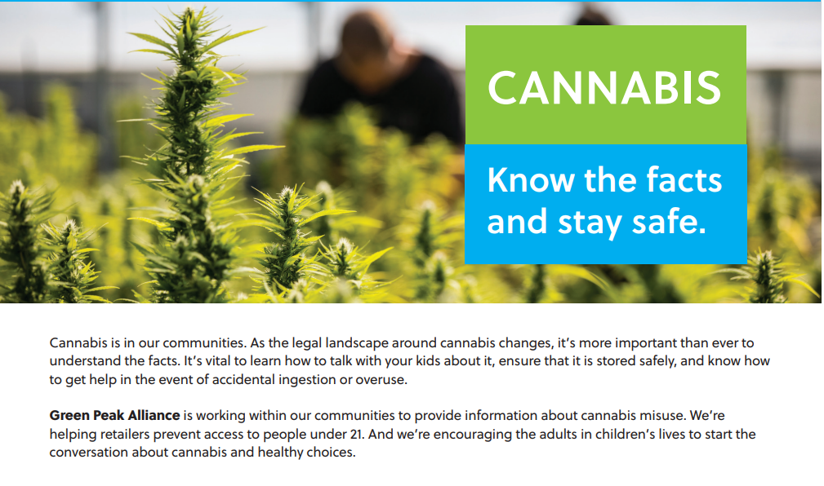
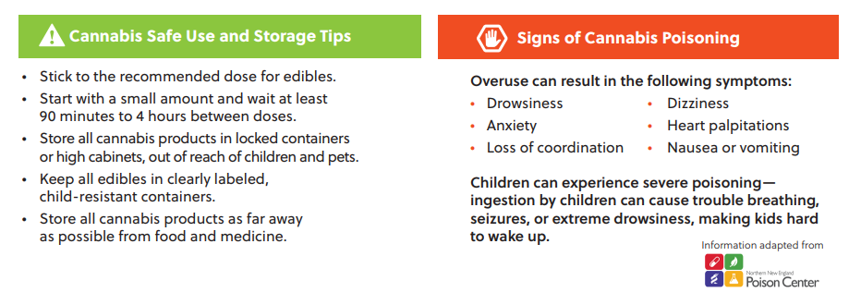

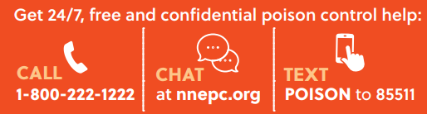

Learn more, get answers to frequently asked questions and access fact sheets here.

“Talk. They Hear You” –
The "Talk. They Hear You." Underage Drinking Prevention National Media Campaign empowers parents and caregivers to talk with children early about alcohol and other drug use.
The “Talk. They Hear You.”® Campaign’s goal is to provide parents and caregivers with the resources they need to address the issue of alcohol and other drugs with children under the age of 21. The campaign has historically equipped parents with the knowledge and skills to increase actions that reduce and prevent underage drinking. Recently, it has expanded its messaging to include other substances such as marijuana and prescription drugs. The campaign now offers resources to help parents talk to children of all ages about alcohol and other drugs.
For more information about this campaign for parents, school staff or community partners, click here.

